Translating Wavewin Areva to Other Languages.

Date: 03 / 02 / 2006

Submitted by: Softstuf, Inc.

TSILang:

Softstuf uses the TSILang components (http://www.sicomponents.com/tsilang1.html) developed by SIComponents, to translate all text captions, hints, strings etc.., in the source code to French and other languages. The TSILang components allow for us to perform the translations using the TSILang SIL Editor application.

Download & Run SIL Editor:

The SIL editor along with the Wavewin Areva.SIL and Wavewin Areva.SIB files are available on the www.wavewinarev.com web site under the beta page. Click on the TSILang Translation Application link. Save the contents of the zip file to the Wavewin Areva folder.

Run the SIL editor by double clicking on the SILEditor.exe file.

Open the Wavewin Areva.SIL file by selecting the Open menu option from the File menu, navigate to the Wavewin Areva folder and double click on the Wavewin Areva.SIL file.

Translate:

SIL Editor:
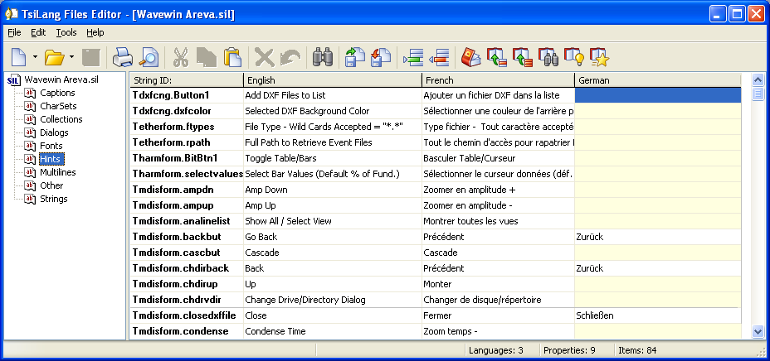
SIL Editor

Enter all translations under the appropriate columns. You can first try to extract the translation from the dictionary using the “Get Translation for Selected Cell” menu button. Also when you first start translating you can use the “Translate All Cells” menu button to automatically retrieve items that are defined in the dictionary.

After translating it is good practice to copy the translated cells to the dictionary for backup. To copy the selected row only click on the “Add Selected Row to Dictionary” menu button. To copy all rows click on the “Add all rows to the Dictionary” menu button

All French and other language conversion entered into the SIL Editor will be translated in the Wavewin Areva software at runtime. The source code does not have to be recompiled to see the changes made in the SIL Editor.

Menu Items:
All Wavewin Areva menu items are included in the SIL file. Each menu item has a shortcut key associated with it. For example: Help, H is the shortcut key for that menu item. To define a shortcut key in the SIL editor you place the & character in front of the shortcut character. Example: Help is defined as &Help in the editor. When translating menus try to keep the same character as the English version. If the character does not exist in the translate word them select a new character and test in Wavewin Areva if it is a duplicate shortcut key under the same menu.

Adding Another Language:
To add an additional language select the “Add Language” menu option under the “Tools” menu. Enter the name for the new language and press enter or click Ok. A new column will be added to the tables. The new language will be automatically added into the Wavewin Areva software.

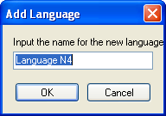
Add New Language Dialog

Save SIL & Export to SIB:

Wavewin Areva reads all translations from the SIB binary equivalent file. The SIB file is read much faster then the SIL file. After editing and saving the SIL file export it to the SIB format. To export the Wavewin Areva.SIL file select the “Export” command under the “File” menu or click on the “Export” menu button . In the Export dialog navigate to the Wavewin Areva folder, select the Wavewin Areva.SIB file and click Save. If Wavewin Areva.SIB does not exist in the Wavewin Areva folder then type Wavewin Areva.SIB in the file name field.

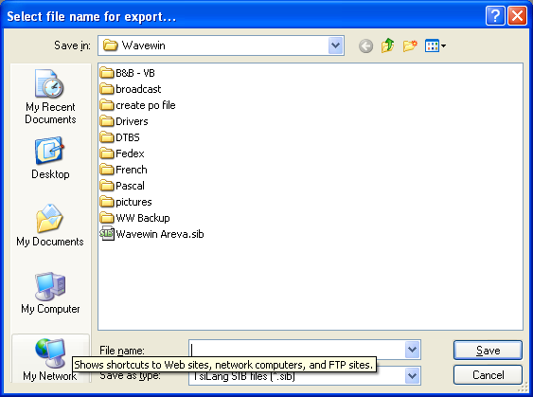
Export Dialog

